TITLE OF THE PROJECT

[Enforce least-privilege access through
identity-aware, application-specific access
policies using Zscaler Private Access (ZPA).]

LIST OF TEAMMATES :

Name: T.M KEWIN CRIFLO
College: BISHOP APPASAMY COLLEGE OF ARTS AND SCIENCE
Contact:kewincriflo@gmail.com

PROJECT DETAILS :

TITLE : Enforce least-privilege access through identity-aware, application specific access policies using Zscaler Private Access (ZPA).

INTRODUCTION :

In an era where the digital landscape is constantly evolving, organizations face an ever-increasing threat from
cyberattacks. The need for swift and effective incident response has become paramount to safeguard sensitive
data, protect digital assets, and maintain the trust of stakeholders. In response to this growing challenge, we
present a visionary project: the development of an AI-driven incident response platform that empowers
cybersecurity teams with the tools to automate and enhance incident triage and response tasks.
In response to the evolving threat landscape and the dissolution of the traditional network perimeter,
modern enterprises are rapidly shifting away from legacy VPN-centric remote access models. These
conventional approaches often grant excessive network-level access, creating a significant attack
surface and increasing the risk of lateral threat movement. To address these challenges, this project
centers on the implementation of a Zero Trust security architecture, fundamentally operating on the
principle of "never trust, always verify." By moving beyond location-based access, we aim to establish a
security posture where trust is no longer implicit, and access is determined by granular context rather
than network connectivity.
The core of this initiative involves the deployment of Zscaler Private Access (ZPA), a cloud-delivered
Zero Trust Access solution designed to create identity-aware, application-specific connectivity. Unlike
traditional VPNs that place users on the internal network, ZPA leverages a "service-initiated" model to
establish direct, one-to-one connections between authorized users and specific applications, completely
hiding the corporate network and IP address space from the internet. This ensures that users connect
exclusively to the applications they are permitted to access, based on continuous identity verification
and context, rendering the applications invisible to unauthorized users and preventing common attack
vectors such as port scanning and distributed denial-of-service (DDoS) attacks.
Ultimately, this project will enforce a least-privilege access model, ensuring users and devices are
granted the minimum required access necessary to perform their functions. By decoupling application
access from network access, we will eliminate the risk of lateral movement across the network, as users
have no visibility or connectivity to other hosts. This strategic move not only significantly enhances
security by reducing the attack surface but also simplifies the user experience and reduces operational
overhead associated with legacy remote access infrastructure, positioning the organization at the
forefront of secure and efficient access management.

ABSTRACT :

The proliferation of hybrid work and cloud-based resources has rendered traditional perimeter-based
security models, such as VPNs, obsolete and increasingly dangerous. These legacy solutions often
provide overly broad network access, exposing organizations to significant risks including lateral threat
movement and an expanded attack surface. This project addresses these vulnerabilities by
implementing a Zero Trust Architecture (ZTA) utilizing Zscaler Private Access (ZPA). The primary
objective is to transition from network-centric to identity-centric access, thereby enforcing the principle
of least privilege.

The methodology involves deploying ZPA’s cloud-based service to create application-specific, identity-
aware micro-tunnels. Unlike conventional VPNs that place users on the internal network, this solution

establishes direct, one-to-one connections between verified users and authorized applications. The
network infrastructure and all non-authorized applications remain completely invisible to the end-user,
effectively eliminating surface for reconnaissance and attack. Access policies are dynamically governed
by user identity, device posture, and contextual attributes, ensuring that connectivity is strictly limited
to what is explicitly required for specific job functions.
The implementation of ZPA successfully decouples application access from network access, resulting in
a demonstrable reduction in the organization's attack surface and the complete prevention of lateral
movement. This project delivers a robust, scalable, and user-friendly remote access framework that
aligns with modern security best practices. By shifting to an identity-aware, least-privilege model, the
organization significantly enhances its security posture while simultaneously reducing operational
complexity and improving the end-user experience.

USE CASE SCENARIOS :

Scenario 1: Finance Department Access to ERP System
A senior accountant in the finance department needs to access the corporate Enterprise Resource Planning (ERP)
system to process monthly payroll. The user connects from a remote location using their company-managed
laptop. Upon launching the ZPA Client Connector, they authenticate via Azure Active Directory with multi-factor
authentication (MFA). ZPA evaluates the user's identity, group membership (Finance_ERP_Users), device posture
(antivirus active, disk encryption enabled), and connection context. The policy engine determines that the user is
authorized and brokers a secure, direct micro-tunnel to the ERP application only. The user can interact with the
ERP interface, but has no visibility or network-level access to any other internal systems, such as development
servers or the HR database.
Output:
• User authenticated and authorized based on identity and group membership
• Direct micro-tunnel established specifically to the ERP application
• All other internal applications and network segments remain invisible and inaccessible

Scenario 2: Contractor Access to Specific Project Repository
An external software consultant is hired for a three-month project and requires access only to a specific Git
repository hosted on an internal server. The contractor is onboarded as a guest user in the identity provider and
assigned to the "Project_X_Contractors" group. When the contractor connects using the ZPA client, the system
verifies their identity and checks the device for basic security compliance (OS patch level, firewall enabled). ZPA
enforces a policy that grants access exclusively to the Git repository application (port 22/SSH or port 443/HTTPS)
during business hours (9 AM to 5 PM). The contractor can clone, push, and pull code, but cannot discover or
connect to any other internal resources, including the corporate intranet or file servers.
Output:
• Time-bound and role-specific access enforced
• Contractor restricted to a single application (Git repository)
• Lateral movement to adjacent systems completely blocked

Scenario 3: Executive Access to Confidential Board Documents
A company executive needs to access a confidential folder containing board meeting materials hosted on an
internal file server. The executive connects from a tablet device while traveling internationally. ZPA integrates
with the mobile device management (MDM) solution to verify that the tablet is compliant (not jailbroken,
passcode enabled, encryption active). Upon successful authentication, ZPA evaluates the policy: "If user is in
'Executive_Board' group AND device is MDM-compliant AND connection is from a trusted country (allowlist),
THEN grant access to 'Board_Documents' application." The executive is connected directly to the specific file
share, and all data in transit is encrypted via TLS. Any attempt to access other shares or network resources is
automatically blocked and logged.
Output:
• Context-aware access based on user role, device posture, and geographic location
• Granular access to a specific file share (Board_Documents)
• Comprehensive logging of access events for audit and compliance
Scenario 4: IT Administrator Access to Server Management Interfaces
A systems administrator requires access to management interfaces (SSH for Linux servers and RDP for Windows
servers) to perform routine maintenance. Instead of granting VPN access to the entire management network, ZPA
is configured to treat each server or management interface as a separate application segment. The administrator
authenticates and is presented only with the specific servers they are authorized to manage based on their IT
subgroup (e.g., "Linux_Admins" see only Linux servers; "Windows_Admins" see only Windows servers). When the
admin connects via SSH to a Linux server, ZPA creates a direct micro-tunnel to that specific IP and port
combination. The admin cannot scan the subnet, access other servers, or initiate connections to non-authorized
ports.

Output:
• Micro-segmentation at the individual server/interface level
• Role-based access controlling visibility of specific management consoles
• Elimination of network-level reconnaissance capabilities for admins

Scenario 5: Mergers and Acquisitions Integration
A company acquires a smaller firm and needs to provide the acquired company's HR team with temporary access
to the parent company's benefits enrollment application. The acquired company's users are added as external
collaborators in the identity provider with limited attributes. ZPA policies are created that specifically grant the
"Acquired_HR" group access only to the "Benefits_App" (a web application hosted internally). The acquired users
install the ZPA client, authenticate, and are connected directly to the benefits application. Because ZPA provides
access without network connectivity, the parent company's entire internal network remains completely hidden
and protected. The acquired users cannot ping, scan, or access any other corporate resource. After six months,
when the integration is complete and users are migrated to the parent identity system, the temporary policies are
revoked.
Output:
• Secure, temporary access provided without network exposure
• Complete network invisibility protecting the parent company's infrastructure
• Simplified deprovisioning through policy revocation rather than complex network changes

STAGE – 1

TITLE : owasp top 10

OVERVIEW :

The OWASP Top 10, published by the Open Worldwide Application Security Project (OWASP), is a globally recognized list that identifies the most critical security risks affecting web applications. It serves as a standard awareness document for developers, security professionals, and organizations to understand common vulnerabilities that attackers frequently exploit. The list is created using real-world data collected from thousands of applications and is updated periodically to reflect the evolving threat landscape. The OWASP Top 10 highlights major security issues such as broken access control, cryptographic failures, injection attacks, security misconfiguration, and server-side request forgery, which can lead to serious consequences including data breaches, unauthorized access, financial loss, and damage to an organization’s reputation. By following the OWASP Top 10 guidelines, organizations can improve their secure development practices, perform better security testing, and build more secure and reliable web applications.

LIST OF VULNERABILITY TABLE :

S.no | Vulnerability Name | CWE/CVE - No
1 | Improper Access Control | 284
2 | Cleartext Transmission of Sensitive Information | 319
3 | SQL Injection | 89
4 | Cleartext Storage of Sensitive Information | 312
5 | XML External Entity (XXE) | 611
6 | Use of Unmaintained Components | 1104
7 | Improper Authentication | 287
8 | Deserialization of Untrusted Data | 502
9 | Insufficient Logging | 778
10 | Server Side Request Forgery | 918

REPORT:
- Vulnerability Name: XML External Entity (XXE)
CWE/CVE: 611
OWASP/SANS Category: Broken Access Control
Description: Broken Access Control occurs when an application does not properly enforce restrictions on what authenticated users are allowed to do. Attackers can access other users’ data, modify records, or perform administrative actions.
Business Impact:
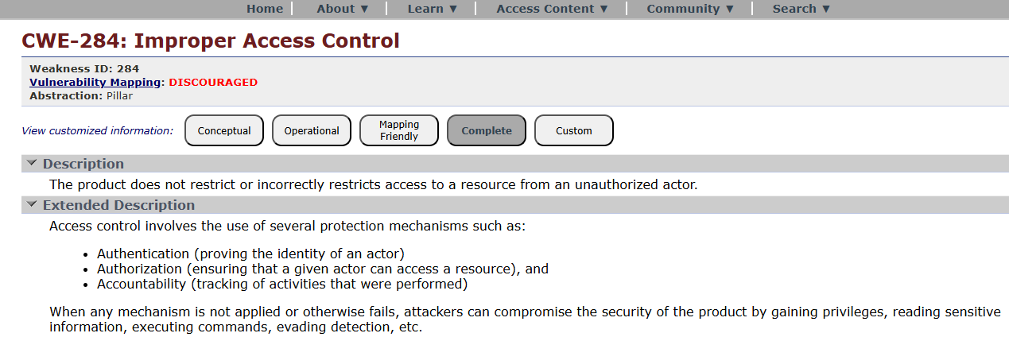

- Vulnerability Name: Cleartext Transmission of Sensitive Information
CWE/CVE: 284
OWASP/SANS Category: Cryptographic Failures
Description: Cryptographic failures occur when sensitive data such as passwords, credit cards, or personal information is not properly encrypted or protected.
Business Impact:
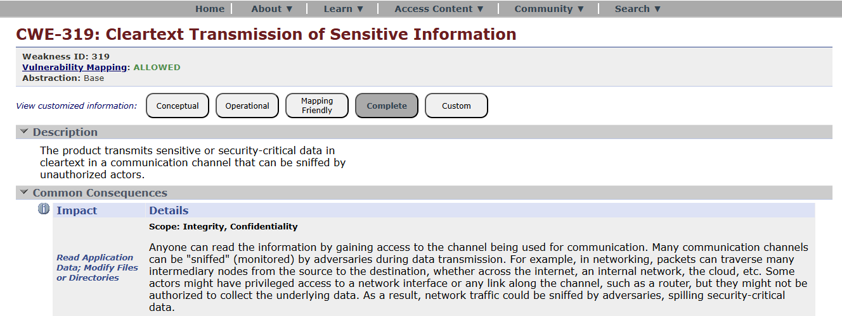
- Vulnerability Name: SQL Injection
CWE/CVE: 89
OWASP/SANS Category: Injection
Description: Injection flaws occur when untrusted user input is sent to an interpreter (SQL, OS commands, LDAP, etc.) without proper validation. Attackers can execute malicious commands.
Business Impact:
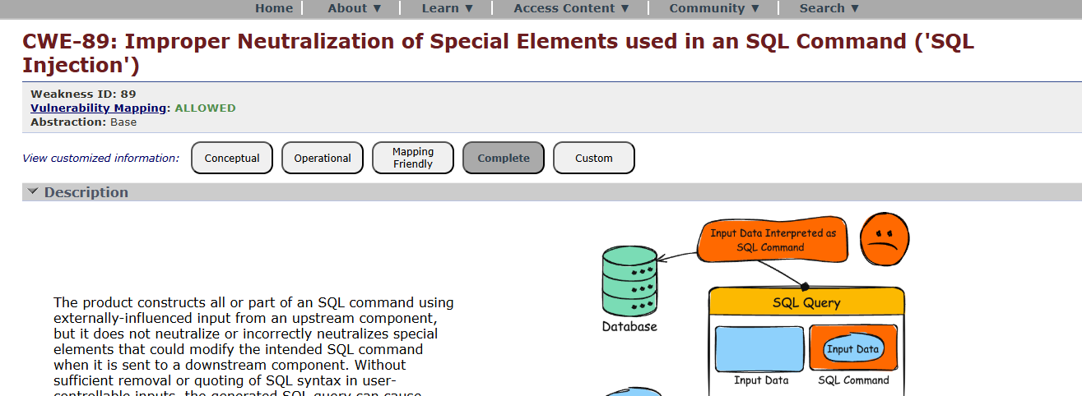

- Vulnerability Name: Cleartext Storage of Sensitive Information
CWE/CVE: 312
OWASP/SANS Category: Insecure Design
Description: Insecure design refers to flaws in system architecture or design that cannot be fixed simply by coding corrections.
Business Impact:
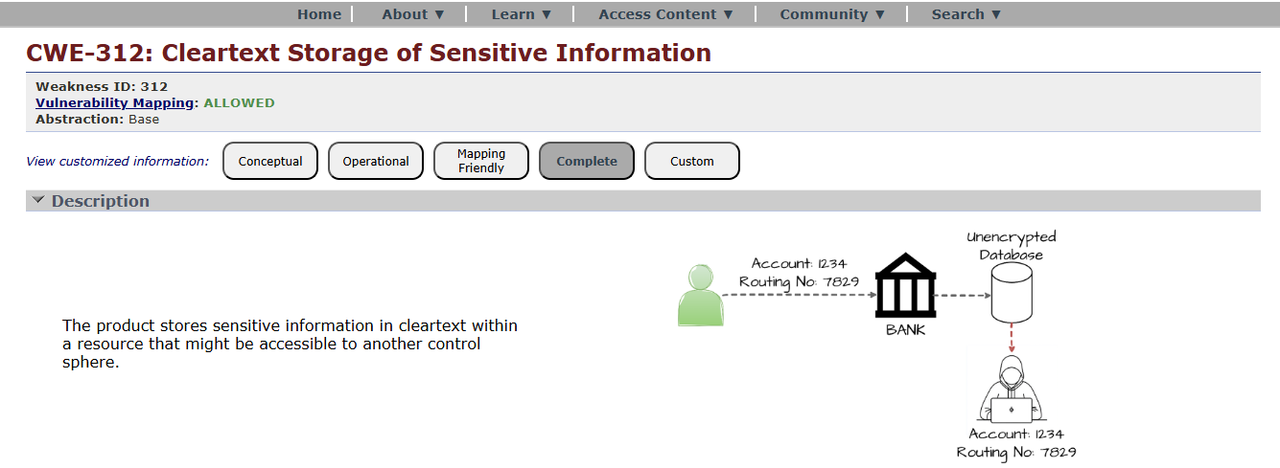
- Vulnerability Name: XML External Entity (XXE)
CWE/CVE: 611
OWASP/SANS Category: Security Misconfiguration
Description: Security misconfiguration occurs when security settings are incorrectly configured or left at default values.
Business Impact:

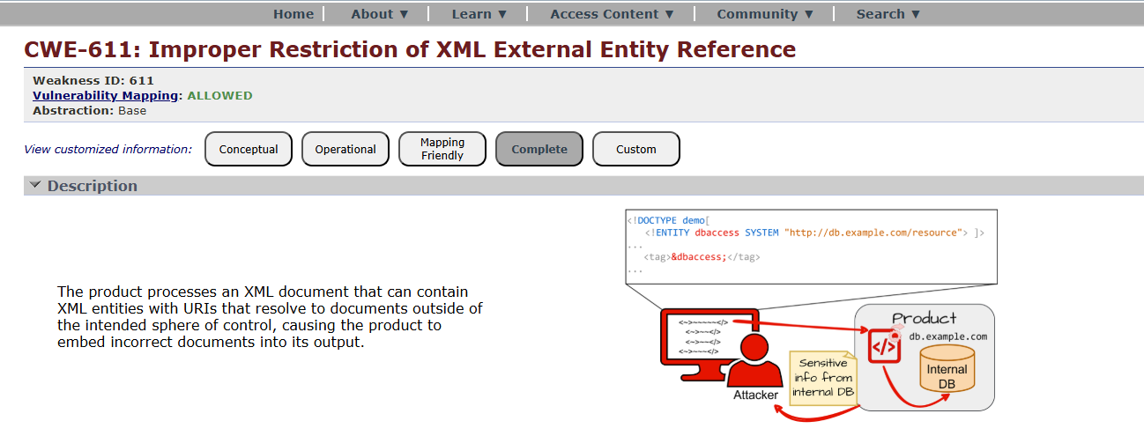
- Vulnerability Name: Use of Unmaintained Components
CWE/CVE: 1104
OWASP/SANS Category: Vulnerable and Outdated Components
Description: Applications may use libraries, frameworks, or software components with known vulnerabilities.
Business Impact:
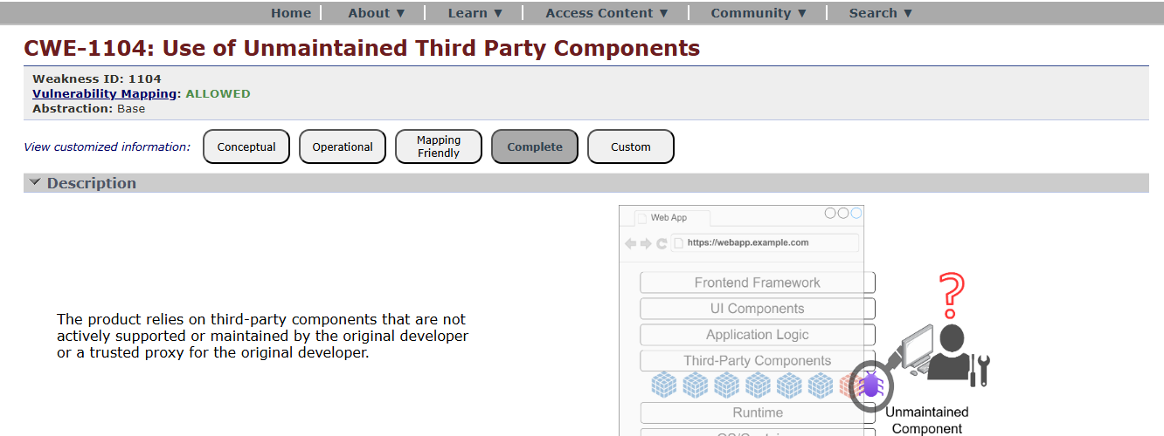
- Vulnerability Name: Improper Authentication
CWE/CVE: 287
OWASP/SANS Category: Identification and Authentication Failures
Description: Occurs when authentication mechanisms are poorly implemented.
Business Impact:
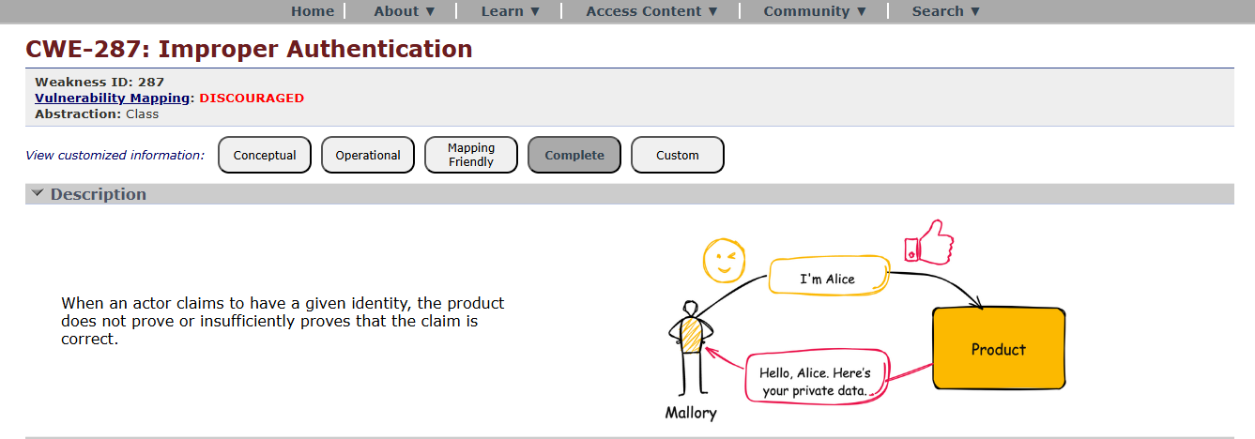
- Vulnerability Name: Deserialization of Untrusted Data
CWE/CVE: 502
OWASP/SANS Category: Software and Data Integrity Failures
Description: This vulnerability occurs when software updates or data are not verified for integrity.
Business Impact:
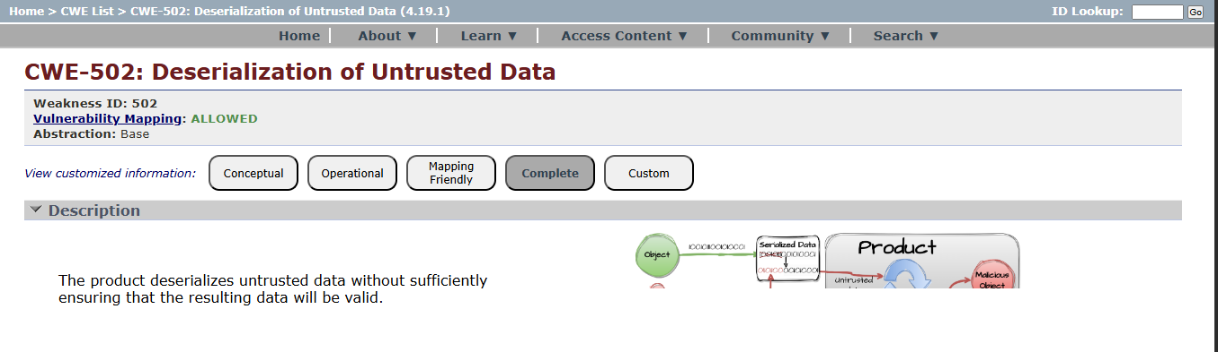

- Vulnerability Name: Insufficient Logging
CWE/CVE: 778
OWASP/SANS Category: Security Logging and Monitoring Failures
Description: Occurs when applications do not properly log security events or monitor suspicious activities.
Business Impact:
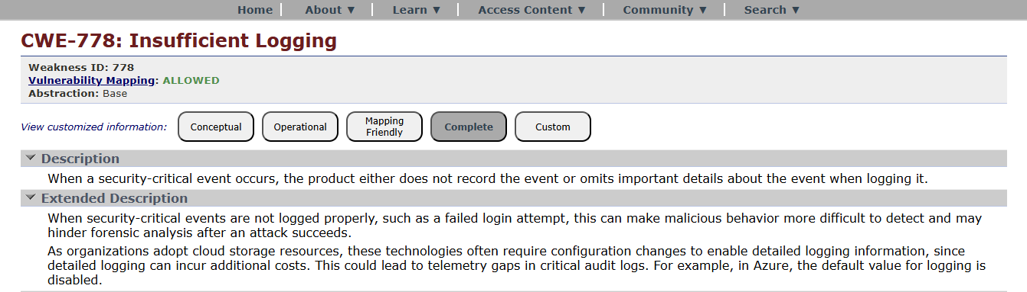
- Vulnerability Name: Server Side Request Forgery
CWE/CVE: 918
OWASP/SANS Category: Server-Side Request Forgery (SSRF)
Description: SSRF occurs when an attacker tricks the server into making requests to internal systems.
Business Impact:
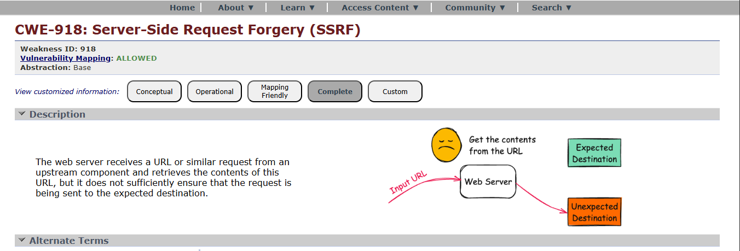

STAGE – 2
TITLE : Nessus Scanner
OVERVIEW :
Nessus scans are a critical component of proactive security, helping organizations identify and address vulnerabilities in their IT infrastructure to reduce the risk of security breaches and data compromises. The frequency and depth of scans can vary depending on an organization's security strategy and requirements.
Nessus is a popular vulnerability scanning tool used for identifying security weaknesses in computer systems and networks. It is widely utilized by security professionals and organizations to assess the security posture of their systems and to proactively identify potential vulnerabilities that could be exploited by attackers. Here's what I understand about Nessus scans:
Vulnerability Assessment: Nessus performs a vulnerability assessment by scanning target systems or networks to identify security issues, such as missing patches, misconfigurations, weak passwords, and other potential weaknesses that could be exploited by attackers.
Network Scanning: Nessus can scan a wide range of network devices, including servers, routers, switches, firewalls, and more. It examines network services, open ports, and software running on target systems.
Plugin Architecture: Nessus uses a plugin-based architecture, allowing it to check for a wide variety of vulnerabilities. These plugins are regularly updated to include the latest security checks and support for new vulnerabilities.
Compliance Auditing: It can also be used to assess systems against various compliance standards and regulatory requirements, helping organizations ensure that their systems meet specific security standards, like PCI DSS or CIS benchmarks.
Customization: Nessus scans can be customized to suit the specific needs of an organization. Users can define scan policies, select the target systems, and specify the types of vulnerabilities to scan for.
Reporting: Nessus provides detailed reports that highlight vulnerabilities, their severity, and remediation recommendations. These reports are essential for IT and security teams to prioritize and address vulnerabilities.
Scanning Frequency: Organizations often perform regular Nessus scans to continuously monitor and improve their security posture. This is crucial for staying ahead of evolving threats and vulnerabilities.
Integration: Nessus can be integrated with other security tools and platforms, allowing organizations to automate the scanning process and streamline their vulnerability management.
Licensing: Nessus offers both free and commercial versions. The free version is limited in its functionality, while the commercial version provides more features and support.
User-Friendly Interface: Nessus offers an easy-to-use web-based interface, making it accessible to a wide range of users, from security experts to less experienced IT professionals.

TARGET WEBSITE : https://public-firing-range.appspot.com
TARGET IP ADDRESS : 142.250.189.180

LIST OF VULNERABILITY :
S. No | Vulnerability Name | Severity | Plugins
1. | Trace out information | info | 10287
2. | Service Detection | info | 22964
3. | SQL Injection | Medium | N/A
4. | Broken Authentication | Low | HSTS Missing from Server
5. | Insecure Direct Object Reference | Info | Service Detection
6. | Security Misconfiguration | Low | SSL cipher Block Chaining cipher suites
7. | Cross-Site Request Forgery | Low | HTTP Form- Based Authentication Detected
8. | Cleartext Transmission of  Sensitive Information | Medium | Cleartext Transmission of Sensitive  Information over HTTP
9. | ClickJacking | Info | HTML Rendering Layer Vulnerability
10. | webserver allows password auto- completion | Low | SSL/TLS Diffie-Hellman Modulus<=1024 bits(Logjam)

Report:
1. VULNERABILITY NAME: Traceroute Information
SEVERITY: INFO
PLUGIN ID: 10287
PORT: 0 / udp
DESCRIPTION: Makes a traceroute to the remote host.
SOLUTION:
• To perform a traceroute to a remote host, you use the command line interface of your operating system. The specific command varies slightly by OS, but the function remains the same: it maps the network path by sending packets with increasing Time-To-Live (TTL) values, identifying each router (hop) along the way
- BUSINESS IMPACT: Reconnaissance & Network Mapping: Attackers use this information to map network topology, identify ISP details, and locate intermediate hops (routers, firewalls) between the attacker and the target, assisting in identifying the network architecture.
- Target Identification (Live Hosts): It helps attackers identify "live" IP addresses, indicating which devices are active and responding, making further, more targeted attacks more efficient.
- Security Control Bypass: By understanding the path data takes, attackers can identify bottlenecks or improperly configured security devices (firewalls) that might be bypassed.
- Data Leakage: It provides sensitive information about internal network configuration that should not be visible to unauthorized

Report:
2. VULNERABILITY NAME: Service detection
SEVERITY: info
PLUGIN: 22964
PORT: 80 / tcp / www
VULNERABILITY NAME: SQL injection
SEVERITY: medium
PLUGIN: N/A (typically would be a security testing tool)
PORT: port 80/443
DESCRIPTION: The product constructs all or part of an SQL command using externally influenced
input from an upstream component, but it does not neutralize or incorrectly neutralizes special
elements that could modify the intended SQL command when it is sent to a downstream
component.
SOLUTION:
• If parameterized statements are not feasible, use proper input validation and escaping
mechanisms to sanitize user inputs before they are used in SQL queries. This helps prevent
malicious code injection.
• Utilize stored procedures for database operations. This can help separate SQL code from
application code and reduce the risk of SQL injection.
• Implement strict input validation for all user inputs, ensuring that data adheres to the
expected format and structure.
BUSINESS IMPACT: In summary, it is crucial to underscore that CWE-89, known as SQL Injection,
can exert a profound and diverse business impact. This encompasses critical facets such as data
breaches, financial setbacks, harm to reputation, legal ramifications, and operational turmoil.
Hence, the imperative of preventing and remedying SQL injection vulnerabilities cannot be
overstated, as it is indispensable for fortifying the security and continuity of an organization's
applications and data.
4. VULNERABILITYNAME: Broken authentication
SEVERITY: Low
PLUGIN: HSTS Missing from HTTPS Server (plugin id:142960)
PORT: port 443

DESCRIPTION: The system's authorization functionality does not prevent one user from gaining
access to another user's data or record by modifying the key value identifying the data.
SOLUTION:
• Implement strong authentication mechanisms, such as multi-factor authentication (MFA) or
two-factor authentication (2FA), to ensure that only authorized users can access the system.
• Implement proper authorization controls to ensure that users have the necessary
permissions to access specific functions or data. Use role-based access control (RBAC) to
manage user privileges effectively.
• Deploy intrusion detection and prevention systems (IDS/IPS) to monitor and block
suspicious activities related to authentication and authorization.
BUSINESSIMPACT: To effectively mitigate the business impact of CWE-285, it is imperative that
organizations place a strong emphasis on bolstering their authentication and session management
practices. This should encompass the adoption of multi-factor authentication, the secure storage of
credentials, meticulous session handling, and a commitment to conducting routine security
assessments and testing. The rectification of these vulnerabilities stands as a critical imperative,
safeguarding sensitive data, user identities, and the organization's overarching security stature and
reputation.
5. VULNERABILITYNAME: Insecure Direct object Reference
SEVERITY: Info
PLUGIN:Service Detection (plugin id:22964)
PORT: port 80/443
DESCRIPTION: Insecure Direct Object Reference (IDOR) is a vulnerability that arises when
attackers can access or modify objects by manipulating identifiers used in a web application's
URLs or parameters. It occurs due to missing access control checks, which fail to verify whether a
user should be allowed to access specific data.
SOLUTION:
• Utilize parameterized queries or prepared statements when interacting with databases. This
prevents user-controlled input from being executed as SQL code.
• Implement a Content Security Policy to mitigate the risk of cross-site scripting (XSS) attacks,
which can be used to execute unauthorized queries.
• Implement account lockout mechanisms that temporarily suspend accounts after a specified
number of unauthorized access attempts to prevent brute force attacks.
BUSINESS IMPACT: To effectively mitigate the business impact of CWE-639, organizations must
make it a top priority to fortify their access control and authorization mechanisms. This entails the
implementation of robust security measures, the regular conduct of comprehensive security
assessments, and the deployment of intrusion detection systems to promptly identify and counter
unauthorized access attempts. These measures stand as critical in the defence of sensitive data, the
overall security of systems, and the preservation of the organization's esteemed reputation.
6. VULNERABILITY NAME: Security Misconfiguration

SEVERITY: low
PLUGIN: SSL cipher Block chaining cipher suites
PORT: port 443
DESCRIPTION: The product specifies permissions for a security-critical resource in a way that
allows that resource to be read or modified by unintended actors.
SOLUTION:
• Implement a change management process to document and review all changes to system
configurations. This helps prevent unauthorized or unintended alterations.
• Follow security guidelines provided by software and hardware vendors to ensure secure
configurations.
• Regularly perform compliance checks against industry standards and regulations to ensure
that configurations remain in compliance with security requirements.
BUSINESS IMPACT: To effectively lessen the business consequences stemming from CWE-732,
organizations must place a strong emphasis on bolstering their configuration management
practices. This involves the establishment of secure default settings, the routine conduct of
comprehensive security evaluations, and the deployment of intrusion detection systems to
promptly detect and address misconfigurations and vulnerabilities. These actions are of
paramount importance in safeguarding sensitive data, fortifying system security, and preserving
the organization's esteemed reputation.
7. VULNERABILITYNAME: Cross-Site Request Forgery
SEVERITY: Low
PLUGIN:HTTP Form-Based Authentication Detected
PORT: port 8080/443
DESCRIPTION: Cross-Site Request Forgery (CSRF) is an attack that forces an end user to execute
unwanted actions on a web application in which they’re currently authenticated. With a little help
of social engineering (such as sending a link via email or chat), an attacker may trick the users of a
web application into executing actions of the attacker’s choosing. If the victim is a normal user, a
successful CSRF attack can force the user to perform state changing requests like transferring
funds, changing their email address, and so forth. If the victim is an administrative account, CSRF
can compromise the entire web application.
SOLUTION:
• Implement Synchronizer Token Patterns to include unique, randomly generated tokens in
each HTTP request and validate these tokens on the server side to verify the authenticity of
the request.
• Utilize the Same Site attribute in cookies to restrict their usage to same-site requests only,
preventing them from being sent along with cross-site requests and effectively mitigating
CSRF attacks.

• Utilize framework-specific protections and security features to prevent CSRF attacks. Many
modern web frameworks have built-in mechanisms and libraries for handling CSRF
vulnerabilities effectively.
• Implement a Content Security Policy to restrict the sources from which various types of
content can be loaded. By specifying the trusted sources of content, you can minimize the risk
of malicious code execution and reduce the likelihood of successful CSRF attacks.
BUSINESS IMPACT: To effectively reduce the business repercussions of CWE-352, organizations
must prioritize secure coding practices, including the incorporation of anti-CSRF tokens, while also
conducting routine security assessments and testing to detect and rectify CSRF vulnerabilities.
Furthermore, educating users on secure browsing practices is pivotal in preventing CSRF attacks.
These actions are of paramount importance in the protection of data and in upholding the trust of
customers and partners.
8. VULNERABILITYNAME: Cleartext Transmission ofSensitive Information
SEVERITY: Medium
PLUGIN: Cleartext Transmission ofSensitive Information overHTTP
PORT: port 443
DESCRIPTION: The product transmits sensitive or security-critical data in cleartext in a
communication channel that can be sniffed by unauthorized actors. Many communication channels
can be "sniffed" (monitored) by adversaries during data transmission. For example, in networking,
packets can traverse many intermediary nodes from the source to the destination, whether across
the internet, an internal network, the cloud, etc. Some actors might have privileged access to a
network interface or any link along the channel, such as a router, but they might not be authorized
to collect the underlying data. As a result, network traffic could be sniffed by adversaries, spilling
security-critical data.
SOLUTION:
• Educate users and employees on secure data handling practices, such as recognizing secure
websites (look for "https") and avoiding insecure Wi-Fi networks.
• Employ data masking or redaction techniques to replace sensitive data with placeholders or
cryptographic representations during transmission.
• Implement encryption for data in transit. Use secure encryption protocols such as TLS/SSL to
protect sensitive information during transmission.
• Use secure communication protocols for transmitting data, such as HTTPS for web
applications, and ensure that the selected protocols are kept up to date.
BUSINESSIMPACT: To effectively reduce the business consequences associated with CWE-319,
organizations must prioritize the adoption of secure data transmission practices. This includes the
utilization of encryption and robust, secure protocols. The routine conduct of security assessments
and testing is pivotal in pinpointing and remedying vulnerabilities linked to data transmission.
Furthermore, the education of users on secure data handling practices plays a vital role in
proactively preventing data exposure incidents. These actions are of paramount importance in the
protection of sensitive data and in preserving the trust of both customers and partners.
9. VULNERABILITY NAME: Clickjacking

SEVERITY: Info
PLUGIN:HTML Rendering Layer Vulnerability
PORT: port 80/443
DESCRIPTION: The web application does not restrict or incorrectly restricts frame objects or UI
layers that belong to another application or domain, which can lead to user confusion about which
interface the user is interacting with.
SOLUTION:
• Set the X-Frame-Options HTTP response header to deny or same-origin to control how your
site can be framed. This is supported by most modern browsers.
• Utilize frame-busting JavaScript code in web applications to prevent the embedding of your
site within malicious frame’s. This code can disrupt clickjacking attempts.
• Implement a Content Security Policy to restrict which domains can embed your site in
iframes. This can help prevent unauthorized framing.
• Implement additional security controls to prevent UI redress attacks, such as clickjacking,
within your web application.
BUSINESS IMPACT: To effectively reduce the business consequences resulting from CWE-1021,
organizations must prioritize the implementation of protective measures, such as frame-busting
code. Simultaneously, educating users on safe browsing practices plays a crucial role in preventing
clickjacking incidents. Additionally, routine security assessments and testing are pivotal for
identifying and mitigating vulnerabilities associated with clickjacking. These actions are of
paramount importance in upholding user trust, ensuring data protection, and safeguarding the
organization's reputation.
10. VULNERABILITY NAME: web server allows password auto-completion
SEVERITY: Low
PLUGIN: SSL/TLS Diffie-Hellman Modulus <= 1024 Bits (Logjam)
PORT: port 443
DESCRIPTION: Weaknesses in this category are related to the design and implementation of data
confidentiality and integrity. Frequently these deal with the use of encoding techniques, encryption
libraries, and hashing algorithms. The weaknesses in this category could lead to a degradation of
the quality data if they are not addressed.
SOLUTION:
• Implement secure password storage mechanisms, such as using strong and salted
cryptographic hashing algorithms like crypt or script.
• Implement robust encryption key management practices, including secure key storage, key
rotation, and access controls.
• Utilize well-established and proven cryptographic libraries and algorithms for encryption
and decryption.

• Use secure encryption protocols, like TLS/SSL, for data transmission over networks to
protect data in transit
BUSINESS IMPACT: To effectively lessen the business consequences associated with CWE-310,
organizations must prioritize the adoption of secure cryptographic practices. This entails ensuring
proper password storage and robust encryption key management. Simultaneously, conducting
routine security assessments and testing is pivotal in detecting and mitigating vulnerabilities
related to cryptographic issues. Striving for compliance with pertinent data protection regulations
and industry standards is equally essential. These actions are of paramount importance in the
protection of sensitive data, the upholding of user trust, and the preservation of the organization's
esteemed reputation.
DESCRIPTION: Nessus was able to identify the remote service by its banner or by looking at the error message it sends when it receives an HTTP request.
- SOLUTION:
- Disable or Configure Banners: Modify the web server configuration (e.g., Apache, Nginx) to suppress server version strings and information in the Server HTTP header.
- Customize Error Messages: Configure the web server to return generic error pages (e.g., a generic 404 page) rather than detailed error messages that disclose technology stacks.
- Use a Reverse Proxy: Place a reverse proxy or Web Application Firewall (WAF) in front of the service to mask the backend technology and banner.
- Network Segmentation: Use firewalls to restrict access to sensitive services, ensuring only authorized traffic can reach them

STAGE – 3
TITLE : Enforce least-privilege access through identity-aware, application-specific access policies using Zscaler
Private Access (ZPA).
Zero Trust Network Access (ZTNA)
Zero Trust Network Access (ZTNA) is a cybersecurity framework that shifts access control from a
network-centric model to an identity-centric model. The foundational principle of ZTNA is "never trust,
always verify," meaning that no user or device is trusted by default, regardless of whether they are
connecting from inside or outside the corporate network. Unlike traditional remote access solutions that
grant users broad access to the entire network, ZTNA creates a secure, application-specific tunnel
between the user and the resources they are authorized to access. This ensures that the application
remains invisible to unauthorized users and the broader internet, effectively shrinking the attack
surface and eliminating the risk of lateral movement across the network.
Zscaler Private Access (ZPA)

Zscaler Private Access (ZPA) is a cloud-delivered ZTNA solution that provides identity- and context-
based access to private applications without granting network-level access. ZPA operates on a "service-
initiated" model, where users connect to the Zscaler cloud, and the cloud brokers a secure connection to

the specific application via ZPA App Connectors deployed in the data center or cloud environment.
Because ZPA never places the user on the corporate network, internal IP addresses and network
infrastructure are completely hidden. Access policies are dynamically enforced based on user identity,
group membership, device posture, and location, ensuring that each user sees only the applications they
are explicitly permitted to use.
Principle of Least Privilege
The principle of least privilege (PoLP) is a security concept in which a user, device, or process is granted
only the minimum levels of access—or permissions—necessary to perform its function. In the context
of network security, this means moving away from "fat" network access (where authenticated users can
reach large segments of the network) to "thin," application-specific access. By enforcing least privilege
through ZPA, organizations ensure that even if a user's credentials are compromised, the attacker
cannot pivot to other systems because the network itself is invisible and inaccessible. This principle is
foundational to reducing insider threats and limiting blast radius during a security incident.

Identity-Aware Access:
Identity-aware access is a security model that bases access decisions on who the user is, rather than
where they are connecting from. ZPA integrates directly with existing identity providers (IdPs) such as
Microsoft Active Directory, Azure AD, Okta, or Ping Identity. This integration allows security teams to
leverage existing user attributes, group memberships, and roles to build granular access policies. For
example, a policy can state that only members of the "Finance" group, using a company-managed device,
can access the "SAP Finance" application during business hours. This ensures that access is tightly
coupled with the user's identity and context, reducing reliance on static IP addresses or network
segments.
Application-Specific Access Policies
Application-specific access policies are the core enforcement mechanism within ZPA. Instead of creating
rules that allow traffic to entire subnets or IP ranges, administrators define policies that target
individual applications or groups of applications. These policies are written in plain language logic and
can incorporate multiple conditions, including user identity, device posture, location, and time of day.
ZPA allows for the segmentation of internal applications—such as HR systems, internal wikis,
development servers, and database interfaces—so that each application has its own unique access
policy. This micro-segmentation ensures that a user authenticated for one application has no visibility
or connectivity to any other application.
ZPA Architecture and Components
The ZPA architecture is composed of several key components that work together to provide secure,
scalable access:

1. Zscaler Cloud (Service Edge): A globally distributed cloud platform that acts as the broker between
users and applications. It handles authentication, policy enforcement, and connection brokering
without sitting in the data path.
2. App Connectors: Lightweight software VMs or containers deployed within the private data center or
cloud environments. These connectors initiate outbound connections to the Zscaler cloud,
eliminating the need for inbound firewall rules. They establish secure tunnels to the ZPA edge and
forward traffic to the internal applications.
3. ZPA Client Connector: A software client installed on end-user devices (Windows, macOS, Linux, iOS,
Android). It authenticates the user, checks device compliance, and establishes a micro-tunnel to the
ZPA edge for application access.
4. Application Segments: Logical groupings of applications defined within the ZPA admin console.
These segments represent the private resources that users need to access.
Implementation Methodology
The deployment of ZPA follows a structured, phased approach to ensure minimal disruption and
maximum security efficacy:
• Phase 1: Discovery and Inventory: Identify all internal applications currently in use. Categorize them
by criticality, department, and user base. Tools like network scanners, configuration management
databases (CMDB), and interviews with department heads are used to build a comprehensive
application inventory.
• Phase 2: Connector Deployment: Deploy ZPA App Connectors in the data center or cloud
environments where the applications reside. This involves provisioning virtual machines (using
VMware, Hyper-V, or cloud-specific images) and configuring them to connect to the ZPA cloud.
• Phase 3: Application Onboarding: Define application segments within the ZPA console. This includes
specifying the IP addresses and ports of the internal applications and associating them with the
appropriate App Connector groups.
• Phase 4: Policy Creation: Integrate ZPA with the corporate identity provider (e.g., Azure AD). Create
granular access policies based on user groups, device posture, and location. Policies are tested in a
simulation mode before enforcement.
• Phase 5: Pilot and Rollout: Select a pilot group of users to test the new access method. Gather
feedback, monitor performance, and refine policies. Gradually migrate user populations from legacy
VPN access to ZPA.
• Phase 6: VPN Decommissioning: Once all users and applications are migrated, the legacy VPN
infrastructure is decommissioned, eliminating a significant attack surface.
Tools and Technologies
• Primary Platform: Zscaler Private Access (ZPA) – The core Zero Trust access broker.
• Identity Provider (IdP): Microsoft Azure Active Directory (AD), Okta, or Ping Identity for user
authentication and group synchronization.
• Endpoint Protection Platform (EPP): Integration with endpoint security tools (e.g., CrowdStrike,
SentinelOne, Microsoft Defender for Endpoint) to assess device posture and hygiene before granting
access.
• Security Information and Event Management (SIEM): Integration with SIEM platforms (e.g., IBM
QRadar, Splunk, LogRhythm) for centralized logging and correlation of access events.
• Virtualization Platforms: VMware vSphere, Microsoft Hyper-V, or public cloud environments (AWS,
Azure, GCP) for hosting ZPA App Connectors.
• Infrastructure as Code (IaC): Tools like Terraform or Ansible for automated deployment and
configuration of App Connectors at scale.
• Digital Experience Monitoring (DEM): Tools to monitor end-user connection quality and application
performance.
Integration with Identity Providers
Integrating ZPA with the organization's existing identity provider is a critical step in establishing
identity-aware access. This integration is typically done via SAML (Security Assertion Markup
Language) or LDAP (Lightweight Directory Access Protocol). Once integrated, ZPA synchronizes user
attributes and group memberships, allowing policies to reference these groups directly. For example,
when a user authenticates via the ZPA Client Connector, they are redirected to the corporate IdP for

credentials and multi-factor authentication (MFA). Upon successful authentication, ZPA receives
identity attributes that are then used to evaluate access policies and determine which applications the
user is allowed to see and connect to.
Device Posture Checking
Beyond user identity, ZPA can enforce policies based on the security posture of the connecting device.
Through integration with endpoint detection and response (EDR) and mobile device management
(MDM) solutions, ZPA can assess factors such as:
• Antivirus software status and definition updates
• Disk encryption status (e.g., BitLocker, FileVault)
• Operating system patch level
• Presence of jailbreak or root compromise on mobile devices
• Real-time risk score from the EDR tool
If a device fails to meet the defined posture requirements (e.g., antivirus is disabled), ZPA can block
access, grant limited access, or trigger a remediation workflow.
Micro-tunneling and Application Visibility
ZPA establishes a secure TLS/DTLS tunnel between the ZPA Client Connector and the ZPA service edge,
and another tunnel between the service edge and the App Connector. Crucially, this creates a direct
"app-to-user" micro-tunnel. The user's device is never placed on the corporate network; instead, traffic
is proxied at Layer 7 (application layer). From the user's perspective, they can only resolve and connect
to the specific DNS names or IP addresses of the applications they are authorized to access. All other
internal resources remain completely invisible, preventing port scanning, vulnerability reconnaissance,
and lateral movement.
Threat Intelligence Integration
To enhance security monitoring, ZPA can be integrated with threat intelligence platforms. Logs
generated by ZPA—including connection attempts, policy violations, and user activity—can be
forwarded to a SIEM (Security Information and Event Management) system. Within the SIEM, these logs
can be correlated with threat intelligence feeds (such as those from MISP) to identify suspicious
behavior. For example, if a user's credentials are used to access an application from an IP address
associated with known malicious activity, the SIEM can trigger an alert, and integration with ZPA can
automatically revoke that user's session.
Incident Response in a ZPA Environment
ZPA significantly streamlines the incident response process. When a potential threat is detected,
security teams can leverage ZPA's capabilities to:
1. Isolation: Immediately revoke access for a compromised user account or device through the ZPA
console, cutting off their connectivity to all internal applications.
2. Forensics: Access detailed logs within ZPA showing exactly which applications were accessed, by
whom, from which location, and for how long.
3. Containment: Because users have no network-level access, a compromised endpoint cannot be used
to scan or attack other internal systems, containing the blast radius.
4. Granular Blocking: Temporarily block access to specific high-risk applications while allowing access
to others, ensuring business continuity during an investigation.
Understanding ZPA: Key Takeaways
Zscaler Private Access represents a fundamental shift in how remote access is architected and secured.
Here are the key aspects to understand about the solution:
1. It is cloud-native: ZPA is delivered entirely from the Zscaler cloud, eliminating the need for hardware
appliances and complex VPN head-end management.
2. It is identity-centric: Policies are built around users and groups, not IP addresses, making access
control more intuitive and aligned with organizational structure.
3. It ensures network invisibility: By never placing users on the network, ZPA renders internal
infrastructure invisible to the internet, preventing reconnaissance and DDoS attacks.
4. It is scalable: The cloud architecture allows ZPA to scale instantly to accommodate thousands of
concurrent users without performance degradation.
5. It supports hybrid environments: ZPA works seamlessly for applications hosted in on-premises data
centers, private clouds, and public cloud environments.

6. It improves user experience: Users get direct, optimized connections to applications without back-
hauling traffic through a centralized VPN concentrator, reducing latency.

Conclusion:
Stage 1: In conclusion, web application testing is a crucial process that ensures the security,
functionality, and reliability of web-based software. It involves a comprehensive evaluation of various
aspects, including user interface, functionality, performance, and security to identify and rectify issues
before they impact end-users. This process not only enhances the quality of web applications but also
bolsters their resilience against potential threats and vulnerabilities. In an age where online services
and applications are integral to our daily lives, effective web application testing is essential to deliver a
seamless and secure user experience.
Stage 2: The Nessus report for the specific website has highlighted key security insights. It identified
vulnerabilities, categorized by severity, with a focus on critical and high-risk issues that need
immediate attention. Recommendations for addressing these vulnerabilities include patching,
reconfiguration, and other security measures, with a priority on actions that can have the most
significant impact. Compliance with industry standards and best practices is considered, ensuring
alignment with recognized security benchmarks like OWASP guidelines. The report underscores the
need for continuous monitoring, regular updates, and ongoing security efforts to maintain a strong
security posture. In summary, the Nessus report offers a clear view of the website's security state,
provides guidance on mitigating vulnerabilities, and stresses the importance of sustained vigilance
against evolving threats.
Stage 3:

The implementation of Zscaler Private Access marks a pivotal shift from a vulnerable, network-
centric security model to a resilient, identity-centric Zero Trust architecture. By enforcing least-
privilege access and rendering private applications invisible to the internet, this project effectively

neutralizes the threats of lateral movement and network-based attacks. The solution not only
fortifies the organization's security posture against modern cyber threats but also delivers a
seamless and high-performance experience for a distributed workforce. Furthermore, the
decoupling of access from the network simplifies IT operations, reduces dependency on legacy
VPN infrastructure, and provides granular visibility into user-application interactions. Ultimately,
this initiative establishes a future-ready foundation for secure digital transformation..
Future Scope:
Stage 1: future scope of web application testing

The future scope of web application testing is promising and evolving rapidly, driven by the
continuous growth of the internet and web-based applications.
Here are some key aspects of its future scope:
▪ Increased Demand: As more businesses and services move online, the demand for web
applications continues to grow. This, in turn, increases the demand for web application testing
to ensure security, reliability, and functionality.
▪ Advanced Technologies: The complexity of web applications is rising with the integration of
advanced technologies like AI, IoT, and blockchain. Testing these cutting-edge applications will
require specialized skills and tools.
▪ Security Emphasis: With the growing number of cyber threats and data breaches, security
testing for web applications will become even more critical. Testers will need to focus on
vulnerabilities, data protection, and compliance with regulations like GDPR.
▪ Mobile and Cross-Browser Testing: Mobile usage is on the rise, and web applications must be
responsive and functional on various devices and browsers. Testing for cross-compatibility will
be essential.
▪ Performance Testing: As user expectations for speed and performance increase, load testing,
stress testing, and other performance testing types will be crucial to ensure web applications
can handle traffic spikes.
Stage 2: future scope of the testing process you understood.
The future scope of the web application testing process, particularly in terms of identifying
vulnerabilities, is exceedingly promising due to the continuous growth of digital platforms, the
escalating importance of cybersecurity, and the ever-evolving threat landscape. Here are some key
aspects that highlight the prospective scope of web application testing for vulnerability discovery:
▪ AI-Driven Testing: The integration of artificial intelligence (AI) and machine learning (ML) into
web application testing tools will revolutionize the way vulnerabilities are identified. AI
algorithms can swiftly scan vast amounts of code and data to pinpoint vulnerabilities that
might elude human testers.
▪ IoT and Mobile App Testing: With the proliferation of Internet of Things (IoT) devices and the
increasing usage of mobile applications, the scope of web application testing will extend to
encompass these areas. Ensuring the security of IoT devices and the interfaces they use will
become critical.
▪ Blockchain and Cryptocurrency Security: As blockchain technology and cryptocurrencies
continue to gain traction, security testing will be imperative to safeguard transactions and
digital assets. Ensuring the robustness of blockchain-based applications will be a specialized
niche in web application testing
. Serverless Architectures: With the adoption of serverless
computing, web application testing will need to adapt to assess the security of serverless
functions and APIs. Ensuring that serverless components are free from vulnerabilities will be
paramount.
▪ Container Security: As containerization technologies like Docker and Kubernetes become
ubiquitous, web application testing will extend to cover container security. This includes
ensuring that container images and orchestration configurations are free from vulnerabilities.

Stage 3: future scope of Zero Trust
The successful deployment of ZPA lays the groundwork for a broader, more integrated security ecosystem.
Future enhancements can be explored to further mature the organization's security capabilities:
▪ Integration with Zscaler Internet Access (ZIA): Converging Private Access (ZPA) with Internet
Access (ZIA) to create a unified Secure Access Service Edge (SASE) platform, managing all web and
private traffic through a single policy framework.
▪ Advanced Device Posture Checking: Moving beyond basic compliance to incorporate real-time risk
scores from EDR tools, blocking access if a device shows signs of active compromise.
▪ Privileged Remote Access: Extending ZPA to third-party vendors and contractors with time-bound,
audited access to specific critical systems, replacing jump boxes and bastion hosts.
▪ IoT/OT Segmentation: Applying the same micro-tunneling principles to Internet of Things (IoT)
and Operational Technology (OT) devices to ensure they can only communicate with specific management servers.
▪ AI-Driven Anomaly Detection: Leveraging machine learning on ZPA logs to detect behavioral
anomalies, such as a user accessing an application at an unusual hour or from a strange location,triggering automated MFA challenges or access revocation.
▪ Cloud Workload Protection: Utilizing ZPA to secure connections between containers and microservices in multi-cloud environments (AWS, Azure, GCP),ensuring east-west traffic betweenworkloads is encrypted and authenticated.
▪ Automated Provisioning/Deprovisioning: Enhancing the identity provider integration to
automatically revoke application access the moment an employee is terminated or changes roles, ensuring near real-time access control
▪ Digital Experience Monitoring (DEM): Implementing DEM tools to proactively monitor the end-
user experience, identifying network latency or application performance issues before they impact productivity.

Topics Explored:
1. Zscaler
2. Zero trust
3. ZPA
4. VPN
5. MISP
6. College Network Information
7. Deployment of SOC in the College
8. Threat Intelligence
9. Incident Response
Tools Explored:
▪ Nessus Scanner

